- A 29 year old brought into ED by ambulance after motor bike accident, complaining from abdominal pain, looked pale

According to EMST protocol, ABCDE

- Findings; patient in early stages of shock
Next step: iv resuscitation, CXR, Neck Xray pelvic Xray, Catheter,

- Patient improved on resuscitation, FAST = free fluid
What is your provisional diagnosis and what is your next step?

likely Splenic injury, need a CT of the chest and abdomen to exclude a small pneumothorax and diagnose cause of intra abdominal bleeding

- Describe this image 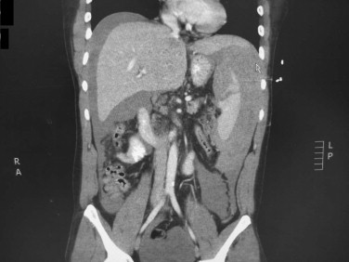

Single coronal image from a CT scan with iv and oral contrast showing free fluid around the liver and the spleen, there is a laceration through the spleen.

- How would you grade splenic injury?
American Association for Surgery on Trauma scoring:

Grade 1 subcapsular haematoma <10% or laceration <1cm
Grade 2 Subcapsular haematoma 10-50% or <5cm or Laceration 1-3cm
Grade 3 Subcapsular haematoma >50% or >5cm or Laceration >3cm
Grade 4 Laceration involving segmental or hilar vessels
Grade 5 Shattered spleen or devascularised

Most Important points are:
- is the patient stable to be observed or unstable, needing intervention
- Are there other injuries that require urgent intervention

- How do you prepare the patient for Open Splenectomy
Consent for laparotomy, splenectomy and further management as required.
2 wide bore iv lines, +/- central line, IV fluid, cross match, Foley’s, NG tube, prophylactic Antibiotics
Good suction, self retaining retractors
GA, Supine position,

- Describe open Splenectomy
- Mid line laparotomy wound extending to the xiphisternum
- 4 quadrant packing
- Inspect the peritoneal cavity for other injuries
- Mobilization of the spleen by dividing the splenophrenic, splenocolic and splenorenal ligaments.
- Mobilization of the spleen from the tail of pancreas as possible
- Ligation of the short gastric vessels
- Ligate the main splenic vessels
- Washout, check for haemostasis, drain
- Closure of the abdomen

- Abdominal closure
Mass technique, using long lasting absorbable suture like PDS, max of 1 cm wide bites, at least 1 cm away from the cut edge, close the corners first and work towards the centre, avoid omentum or fat in between the rectus sheath cut edges.
Suture length 4x wound length.

Small bite technique for fascial closure has been used but it was studied in elective surgery, there are no large studies for this technique in emergency surgery

- What are the risk factors for wound dehiscence and Incisional hernia

Patient factors: Obesity, malnutrition, smoking, immune suppression

Wound factors: infection, radiotherapy

Surgical technique: inappropriate suture, wide bites, excessive tension, loose sutures, knot failure

