Scenario: a 45 year male presented with sudden onset of abdominal pain for the past 3 hours this is his CXR

Ask the following questions:

- Describe this image
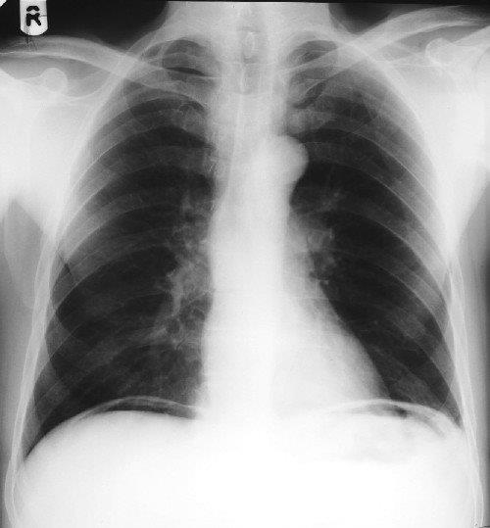
Chest Xray, No bony lesions, central trachea, full lung inflation, clear costo-phrenic angles, normal mediastinal and cardiac silhouette. Free air under the diaphragm.

- How would this patient, usually presents?
Abdominal pain,
O/E tachycardia, possible hypotension, tender and rigid abdomen, might be dehydrated, disturbed consciousness if late or elderly, possibly in shock
Tests: Elevated WBC and inflammatory markers, renal impairment if late.
- What are the possible causes for this situation?
Perforated viscus e.g. Perforated Duodenal Ulcer, perforated gastric Ulcer, perforated diverticulum, traumatic perforation of bowel.
- How would you manage this patient when presenting to ED?
History: General history of symptoms suggestive of peptic/gastric ulcer or change in bowel habit, medication like steroids and non-steroidal, history
Changes in bowel habit, history of diverticulosis.
Examination: vital signs, abdominal exam.
Blood tests
Interventions: oxygen, iv fluid, urinary catheter, admission, iv antibiotics, pain relief

- What would be your next step:
CT scan if vital signs are stable and general condition permits, laparotomy if unstable

- Describe how you perform surgery for perforated DU
- Either laparoscopic or open
- Peritoneal cavity inspection/ wash out
- +/- mobilization of duodenum
- Omental patch to cover the perforation fixed with interrupted suture of absorbable suture like PDS through the duodenal wall, making sure not to pick up the posterior wall
- Larger perforations might require small bowel serosal patch with or without duodenal exclusion.

