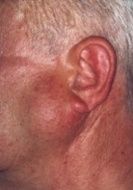
Describe the image: Parotid gland tumour
Describe the Parotid gland
Irregular serous gland on the lateral side of the face, surrounded by a capsule.
- Upper pole close to the cartilage of external acoustic meatus
- Lower pole lies behind the angle of mandible overlapping posterior belly of digastric
- Flat lateral subcutaneous surface
- Anterior border clasp the ramus of mandible with the muscles overlying the bone – the masseter and medial pterygoid
- Facial nerve divides it into deep and superficial
- The deep part is irregular between the mastoid with its attached muscles and the styloid process and its muscles
- The external carotid artery enters partly the deep gland
What are the structures embedded within the parotid gland?
- Facial Nerve
- Retromandibular vein
- External carotid artery
- Lymph nodes and lymphatics

Describe the course of the parotid duct
Duct of Stensen is 5cm long passes forward across the masseter and turns around its anterior border, pierce the buccinator, runs forward under the mucosa for a short distance (creating a valvular flap of mucous membrane) then opens into the mouth opposite 2nd molar tooth

Describe the course of the facial nerve
- Emerge through stylomastoid foramen near origin of posterior belly of digastric.
- Gives the post auricular nerve
- Gives a motor branch to posterior belly of digastric and stylohyoid
- Just before entering the posterior part of the parotid divides into its main two branches Temporozygomatic and Cervicofascial.
- Facial Nerve divides the parotid into deep and superficial parts
- Divides into its 5 main branches within the gland: Temporal, Zygomatic, Buccal, marginal mandibular and cervical

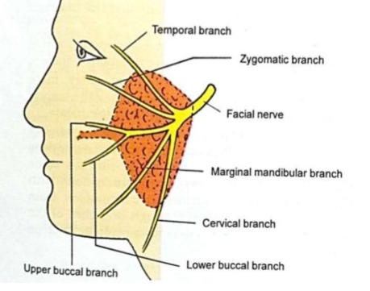

Describe the Course of the left Ureter:
25 cm long. After arising from the uretero-pelvic junction, the ureter descends through the abdomen, along the anterior surface of the psoas major. Here, the ureter is a retroperitoneal structure. It is crossed by the gonadal vessels.
At the area of the sacroiliac joints, the ureter crosses the pelvic brim, entering the pelvic cavity. It crosses the bifurcation of the common iliac artery.
The ureter travels down the lateral pelvic wall. At the level of the ischial spines, turns anteromedially, moving in a transverse plane towards the bladder.
Upon reaching the bladder wall, the ureter pierces its lateral aspect in an oblique manner. This creates a one way valve, where high intramural pressure collapses the ureter – preventing the back-flow of urine.

Describe the blood supply of the Stomach:
Arterial
- Left Gastric artery, branch of the Celiac trunk –runs along the lesser curve
- Right Gastric artery, branch of the Celiac trunk- along the lesser curve
- Left Gastro-epiploic branch of the splenic – runs along the grater curve
- Right Gastro-epiploic branch of the gastroduodenal artery – grater curve
- Few short gastric arteries are branches of splenic artery
Venous
- Right gastric vein drain into the IVC
- Left gastric joins the splenic to form the portal vein
- Left gastro-epiploic vein into IVC
- Right Gastro-epiploic into the splenic or portal vein

Describe the femoral canal
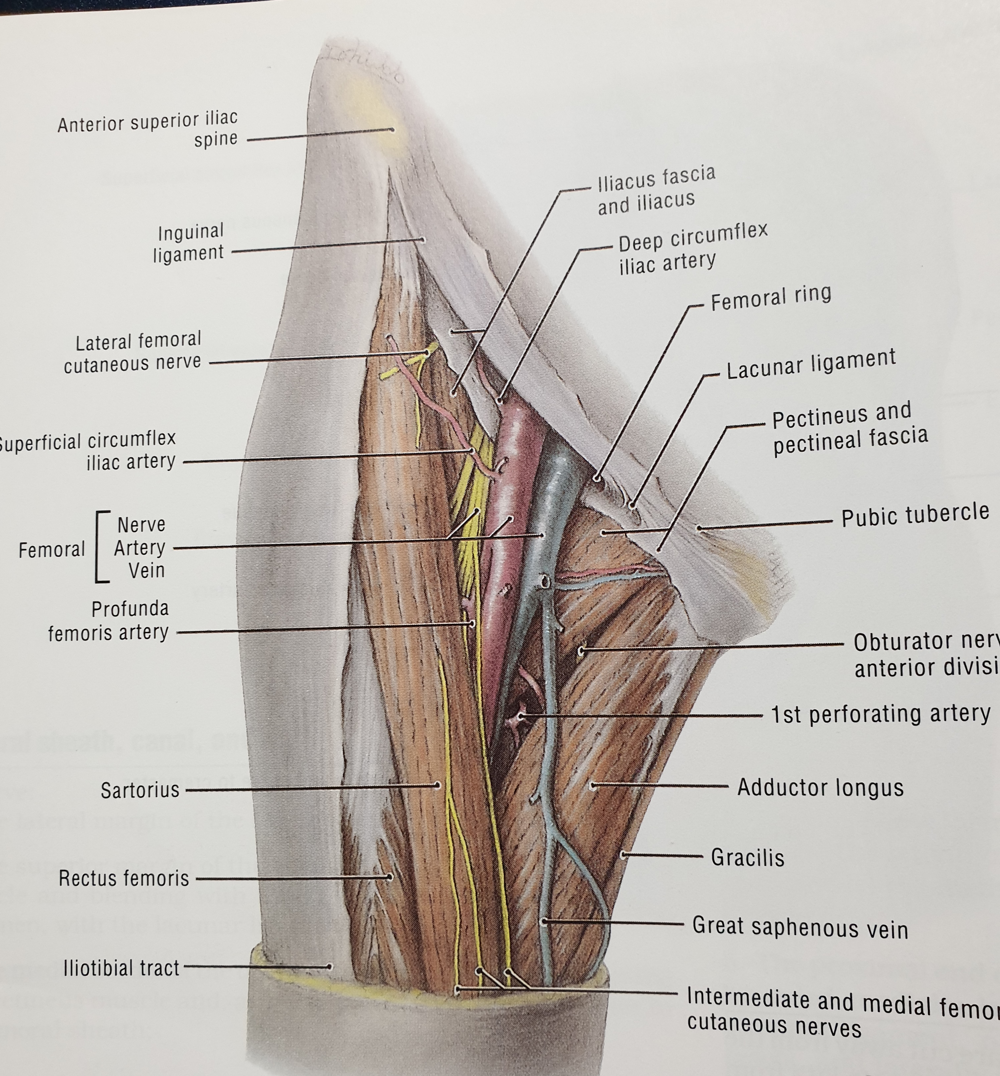
Boundaries:
- Inguinal Ligament
- Medial border of Sartorius
- Medial border of adductor Longus
Base from medial to lateral
- Adductor longus
- Pectineus
- Ileo-psoas
- iliacus
Cover is fascia lata
Contents
- Femoral Canal Femoral vein, artery, nerve
- Greater saphenous vein and
- Origin of profunda femoris artery
- Superficial circumflex iliac artery and vein
- External Pudendal artery and vein
- Superficial epigastric artery and vein
- Lymphatics and lymph nodes

