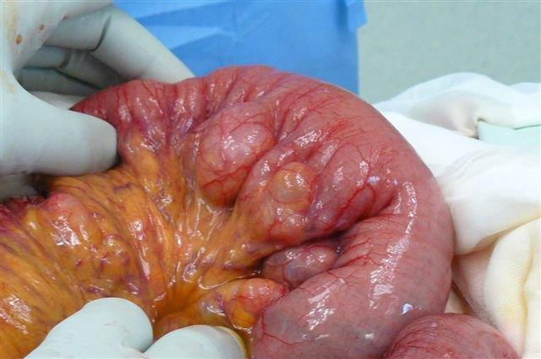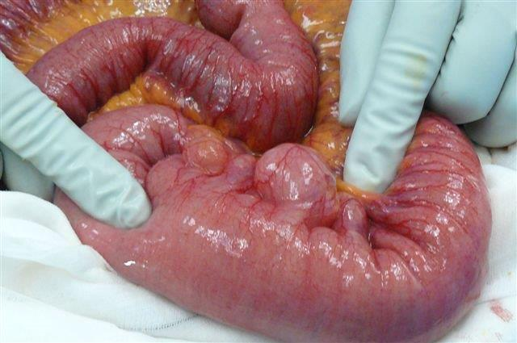

Describe the Image
Intra operative photo showing a segment of small bowel with small bowel diverticulosis.

What is the incidence of this pathology?
Around 1 % of population have jejunal diverticulosis

How do they present?
- Asymptomatic found incidentally through bowel surgery
- Inflammation: Acute central abdominal pain with fever and elevated WBC
- Perforation: Peritonitis with fever, elevated WBC, inflammatory mass on CT +/- free air
- Malabsorption

How do you treat
Treat the presentation:
- Asymptomatic: nothing
- Diverticulitis: bowel rest, iv antibiotics
- Perforation: bowel resection

