Skin Pathology

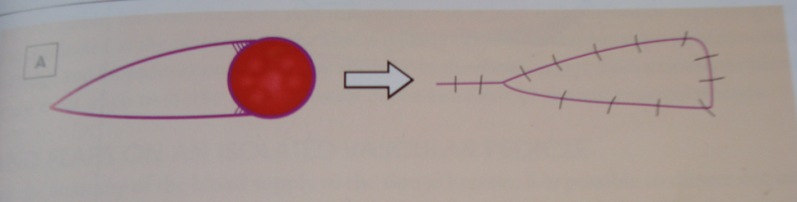

This is an advancement V-Y Flap
After the lesion is excised, a triangular section of skin & Subcutaneous (V shape) is divided, keeping the base attached to the deep fascia for blood supply, the triangular segment is moved forward to close the defect, behind it the skin is closed directly creating the Y shape.

Q1. Describe this lesion 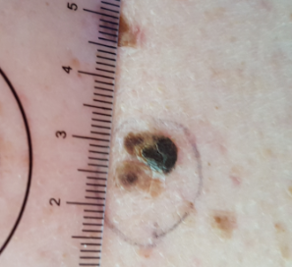

A pigmented skin lesion (use the ABCDE)
- Asymmetric
- Border Irregular
- Colour: pigmented, dark
- Dimension more than 5mm
- Elevated

Q2: What are your most concerned with?

Melanoma

Q3: How would you make a definitive diagnosis?
Excisional Biopsy with 2 mm safety margin with fatty tissue included.

Q4: What are the pathological classifications of the melanoma?
Breslow thickness (depth in mm) and Clarks Classification.

see next slide for teaching

Q5: Histology: patient with 0.4mm deep melanoma Clarke level 3, what is your next step?
Wider excision to complete 1 cm margin of clearance

Q6: What definitive safety margins required for melanoma?
Insitu: safety margin = 5mm
Invasive < 1mm safety margin = 10mm
Invasive 1mm and more Safety margin 2cm + consider SLN

Q7: What are the risk factors for developing melanoma?
- Exposure to Ultraviolet light
- Radiation Therapy
- Immune suppression
- Fair skin Colour, light eye colour, red hair
- Family history

Q8: Point out what are the risk factors you look for in the histology report

CLINICAL DETAILS Pigmented lesion.
MICROSCOPY Sections of skin show superficial spreading melanoma, Clark level 3, Breslow's thickness 0.40mm.
There is a crowded proliferation of melanocytes along the dermal epidermal junction, which extend into and fill the papillary dermis.
Melanocytes have an epithelioid appearance and show sustained significant cytological atypia.
Dermal mitoses are not identified. There is no ulceration or evidence of regression. Lymphovascular space invasion is not seen. There is no neurotropism. There is no desmoplastic melanoma. There are no microsatellite lesions. There is no co-existent benign melanocytic lesion.
Surgical margins: Excision margins are free of malignancy in these sections. In-situ melanoma - peripheral margin 1.5mm. Invasive melanoma - peripheral margin 2.5mm, deep margin >5mm.

Q:9 What do you think this is?

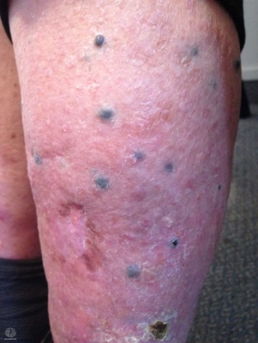 Wide spread melanoma deposits likely in-transit metastasis

Q10: How would you manage this patient? And what are the treatment options?
- Biopsy of one or two lesions for definitive diagnosis
- BRAF gene mutation assessment (BRAF +ve)
- This patient should be assessed with a CT scan or PET scan
- Should be presented in an MDT meeting
- Options are
  - Isolated Limb perfusion
  - Immune suppression with Pembrolizumab (Keytruda)

Q11: What is the BRAF
- BRAF a proto-oncogen on Chromosome 7, when mutated it changes into an oncogene which stimulate the cells for faster division
- 50% of melanoma are BRAF +ve
- Younger patients are more likely to have BRAF mutation
- BRAF +ve melanoma are more aggressive but on the same time more responsive to immune modulators Keytruda
- BRAF mutation is present in other cancers like Small cell lung cancer and urogentital cancers

Q 12: Describe the lesion and what is your differential diagnosis?
Can you give a specific diagnosis?
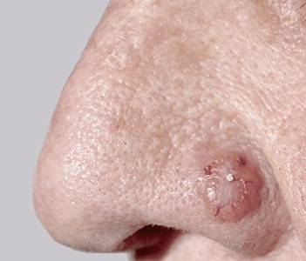

A nodular growth on the left nasal ala approximately 7-8mm in size round in shape with clear margins, it has visible blood vessels running on the surface
Differential: Basal Cell Cancer, Epidermoid cyst, other cystic lesions
Specific diagnosis: Nodular BCC

Q:13: How would you treat:
This lesion will require surgical excision

Q:14 what are the different modalities used for the treatment Non-Melanoma Skin cancers?

- Surgical Excision with different closure options (direct closure, flap closure, skin graft, Secondary intention healing +/_ negative pressure dressing)
- Topical Chemotherapy eg Effudix (5 Flurouracil)
- Topical Immune modulators ( Aldara)
- Liquid Nitrogen application
- Radiotherapy
- Photo-therapy

Q:15 Spot diagnosis:
- Keratin Horn of SCC
- Dysplastic Nevi (Atypical Moles) Advice patient to have mole mapping

