Upper GI : Examiner View

- a. What is the length of the oesophagus?
  - 25cm (starts at 15cm from incisors, 40cm to stomach)

- b. Where are the points of narrowing?
  - Cricopharyngeus (C6, 15cm)
  - Aortic arch (23cm from incisors)
  - Left main bronchus (28cm)
  - Oesophageal hiatus (T10, 38cm)
  - Gastrooesophageal junction (40cm)

- c. What muscle types make up this structure?
  - Skeletal (upper 1/3), mixture (middle 1/3), smooth (lower 1/3)

- This is an endoscopic view of a 60-year-old man’s distal oesophagus. He reports a history of reflux symptoms for many years. Please describe the picture.
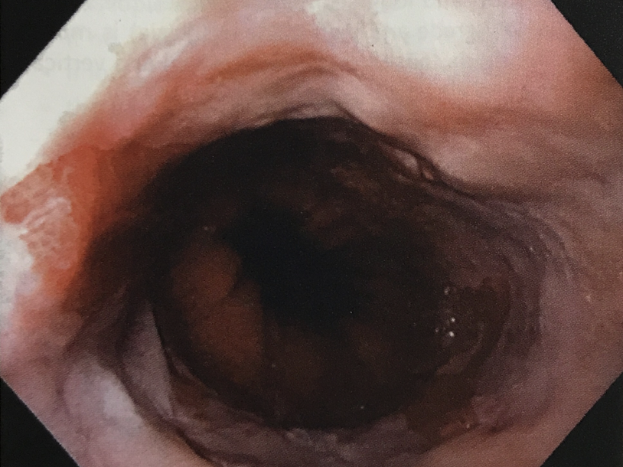
Endoscopic view of the oesophagus approaching the GO junction with salmon flesh coloured mucosa at the 10-11 o’clock likely Barretts mucosa, possible scarring around the area but not very clear on this photo
- How do you define Barrett’s oesophagus?
  - Metaplastic change in oesophageal epithelium with columnar epithelium replacing stratified squamous epithelium of the oesophagus thought to be due to chronic exposure to reflux gastric content
  - Length has to be >1cm because of high inter observer variability, Short segment is 1-3cm, Long segment: >3cm
  - Must contain intestinal metaplasia to be defined as Barrett’s

- What is the difference between the Z-line and the gastrooesophageal junction (GOJ)?
    - Z-line, or squamocolumnar junction, is the visible line formed by the juxtaposition of squamous and columnar epithelium
    - The GOJ is the imaginary line at which the oesophagus ends and stomach begins. The GOJ corresponds to the most proximal extent of the gastric folds.
    - When the Z-line is proximal to the GOJ, there is a columnar-lined segment of oesophagus

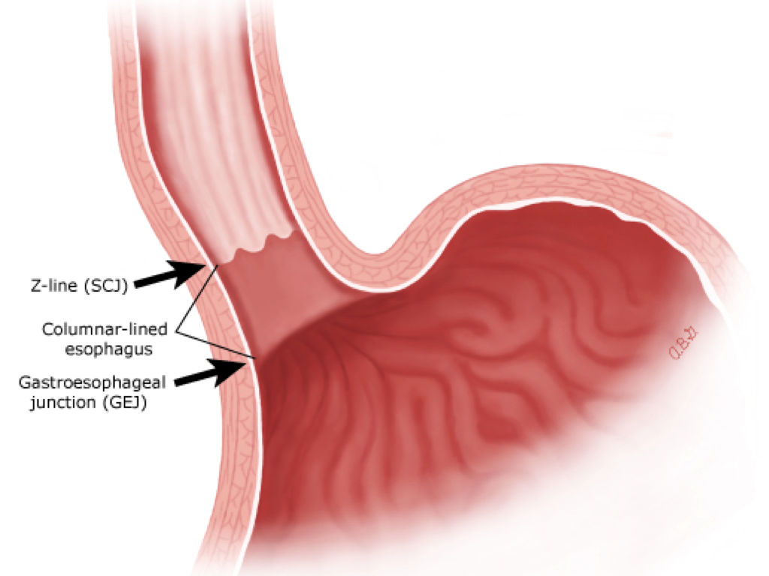

- What are the risk factors for Barrett’s?
  - Age
  - Male gender
  - Smoking, alcohol, obesity are risk factors for reflux disease which predispose to Barrett’s

- How would you perform biopsies for Barrett’s?
  - Biopsy any suspicious area of underlying cancer
  - Perform enough biopsies to detect dysplasia/malignancy
  - Four quadrant biopsies every 1-2cm,
  - Accurately identify site to record on pathology form and obtain biopsy using large endoscopic biopsy forceps

- How would you treat this patient?
  - Modify risk factors
  - Treat reflux symptoms
  - PPI
  - Endoscopic surveillance of the oesophagus
  - if no dysplasia, rescope in 3 years, continue PPI
  - if low grade dysplasia, get second opinion from a pathologist, re-scope at 6 months x2 then yearly (depending on local guidelines)
  - If high grade, end surveillance, and consider oesophagectomy or ablative surgery
  - Fundoplication as a prevention for progression and treatment of reflux

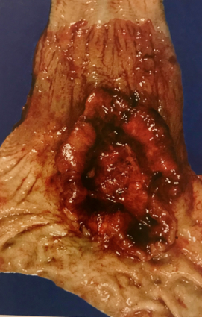
- This specimen was resected from a 70 year old man with dysphagia on a background of worsening symptoms of reflux.
Please describe the picture

  - image shows distal oesophagus at its junction with the stomach containing a large, ulcerative lesion suggestive of a primary oesophageal malignancy
  - >90% of oesophageal cancers are SCC or adenocarcinoma
  - 75% of adenocarcionomas are located in distal oesophagus, whereas SCC is evenly distributed between the middle and lower third.

- What are the risk factors for oesophageal SCC and adenocarcinoma?
  - Mucosal injury due to oxidative factors such as
    - Smoking
    - Trauma
    - inflammation
Risk factors for SCC (most common type) of oesophagus include
  - socioeconomic and dietary factors (smoking, alcohol abuse, hot beverages, low SES)
  - Corrosive injury - ingestion of caustic agents
  - Achalasia
  - History of head and neck/thoracic radiation
  - Plummer-Vinson syndrome, palmoplantar keratosis
  - Human papilloma virus infection
  - Coeliac’s disease
Risk factors for adenocarcinoma of oesophagus:
  - GORD
  - Smoking, obesity, race, gender

- How would you treat this patient?
  - Discuss at MDM
  - Treatment depends of site, type and stage (Curative vs palliative intent)
  - Fitness of patient/patient wishes
  - Specific treatments:
  - Not fit, no metastatic disease = definitive chemoradiotherapy
  - Fit + no metastatic disease = oesophagectomy
  - Fit + metastatic disease = palliate chemo/radiotherapy +/- stenting
  - Frail + metastatic disease = palliative care

- Describe this photo. What are the differentials? 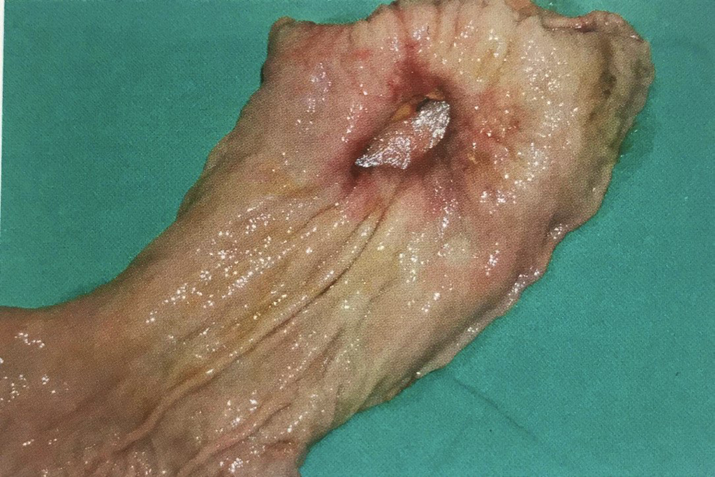

  - This is a specimen of a resected stomach.
  - There is a 2x3cm gastric ulcer in the posterior wall of the stomach.
Differentials:
  - Gastric ulcer
  - Gastric adenocarcinoma
  - Gastric lymphoma
  - GIST
- What is the treatment of perforated gastric ulcer?
  - Surgical - close defect with omental patch
  - Biopsy edge of ulcer (if gastric ca, usually disseminated; if lymphoma, tx usually medical)
  - If defect cannot be closed - distal gastrectomy, gastro-jejunostomy reconstruction (Roux-en-Y)
Duodenal ulcers are invariably not malignant, Omental patch is the usual method of closure unless it is big that would require patching with small bowel +/- duodenal exclusion and gastrojejunostomy.

